**Cyber Security – Assessment # 6**

**Q1**. Vulnerability Assessment is the process of identifying, analyzing, and prioritizing security weaknesses in systems, networks, or applications.

* Install Nessus Expert scanner on Windows 10 machine.
* Carry out vulnerability scanning Acunetix (http://testphp.vulnweb.com/)
* Generate scanning report in PDF format.

**Steps to Download and Install Nessus (14-Day Trial):**

1. Visit the following websites:
   * Temp-Mail: <https://temp-mail.org/>
   * Tenable Nessus: <https://www.tenable.com/products/nessus>
2. Create a temporary email address using Temp-Mail and copy it.
3. Go to the tenable website and paste the Temp-Mail address in the registration form.
4. Use random First Name and Last Name in the registration fields.
5. For other details like Phone, Job Title, Company, and Employee Count, enter random information.
6. Click on the "Start Trial" button.
7. Agree to the licensing agreement and proceed.
8. The Nessus software will start downloading.
9. When Download Use Default Installation and open with Nessus Console.
10. Now Click on “Connect with ssh”

This process allows you to access Nessus with a 14-day trial.

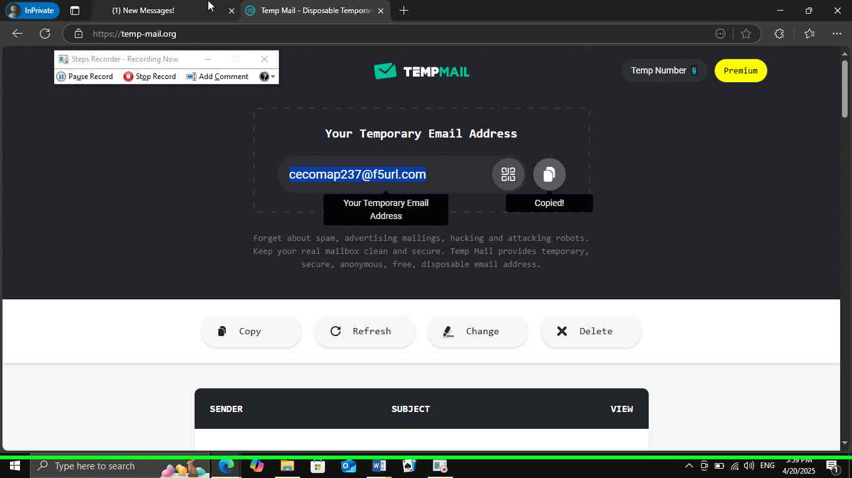

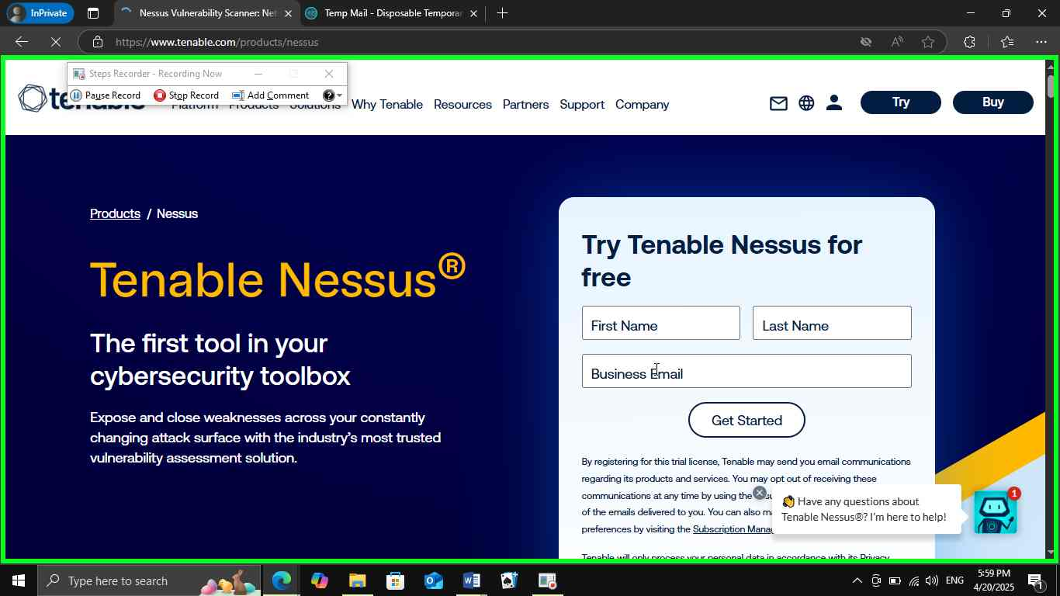

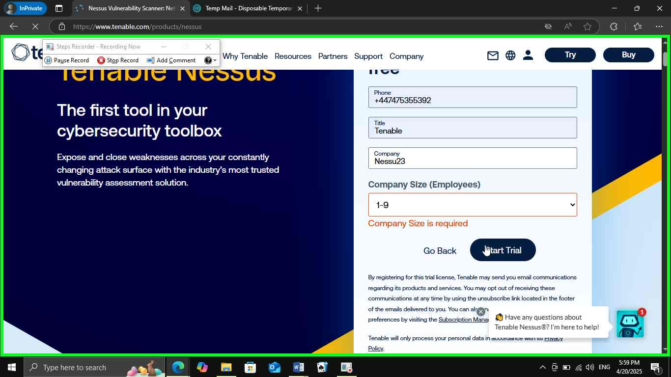

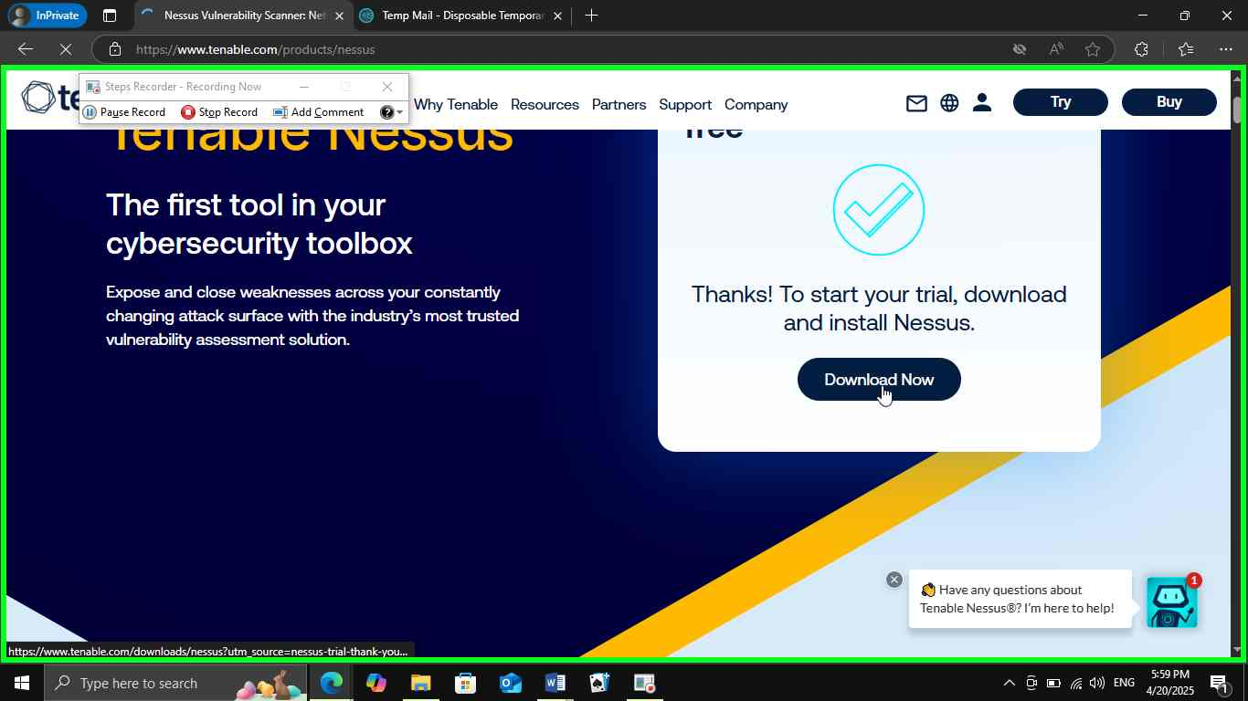

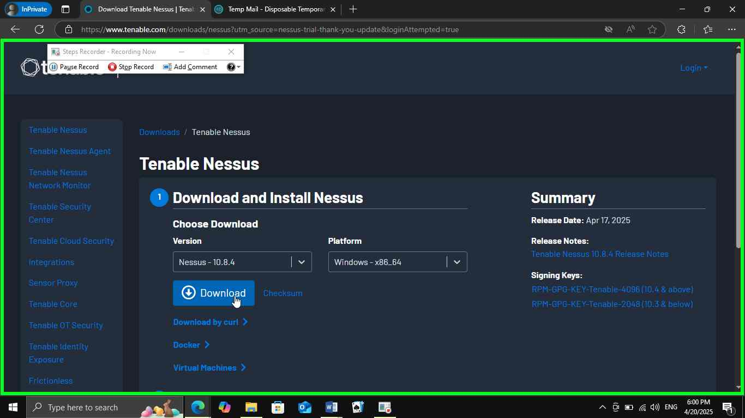

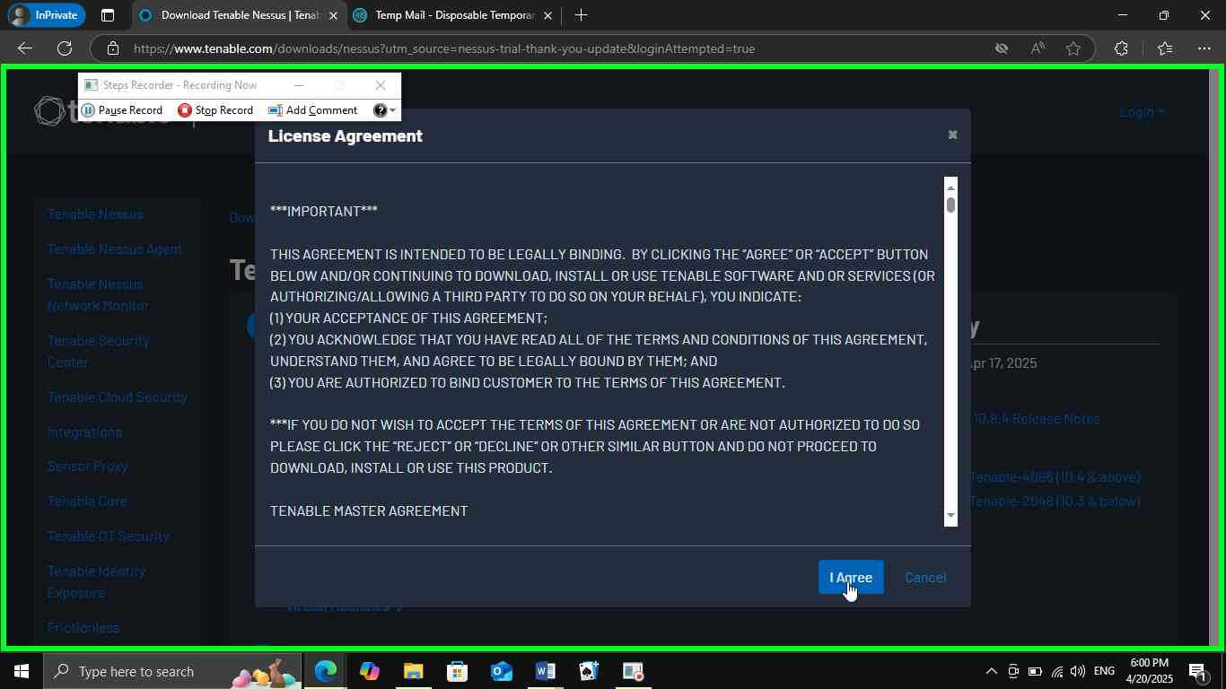

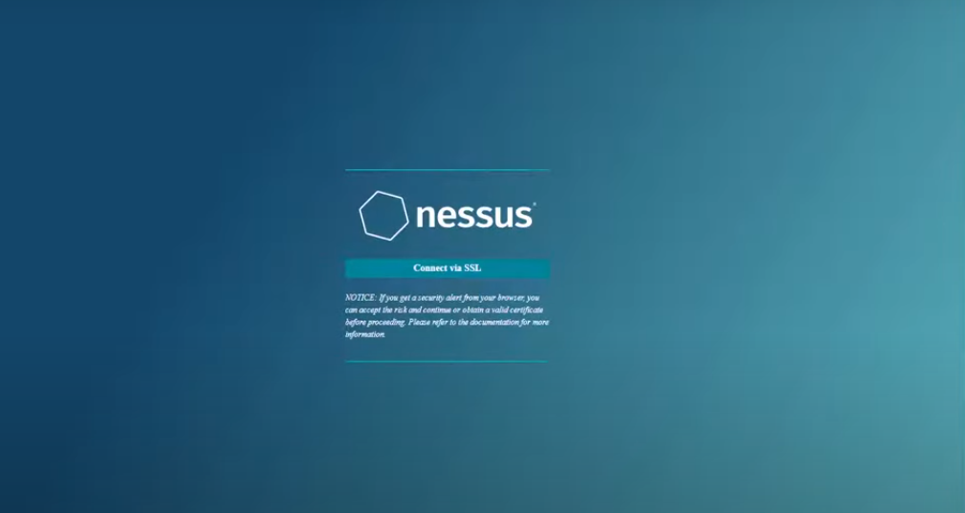

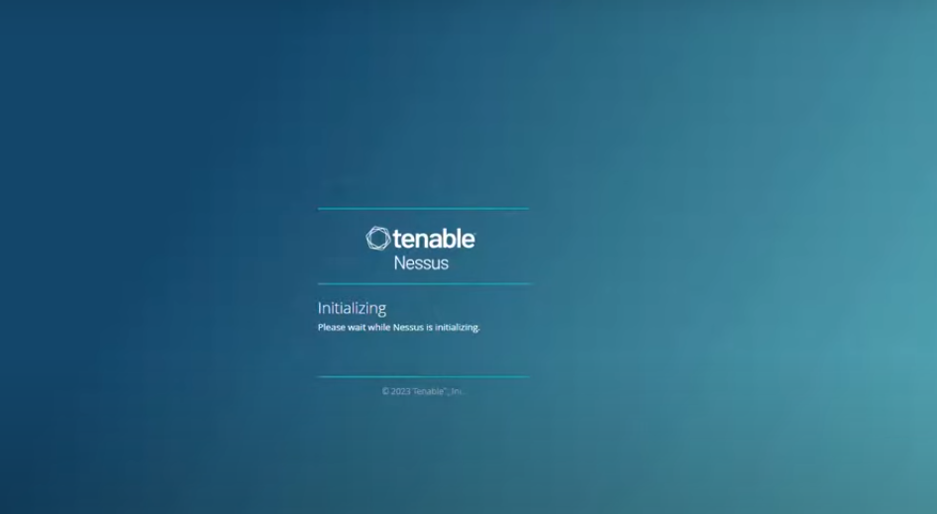

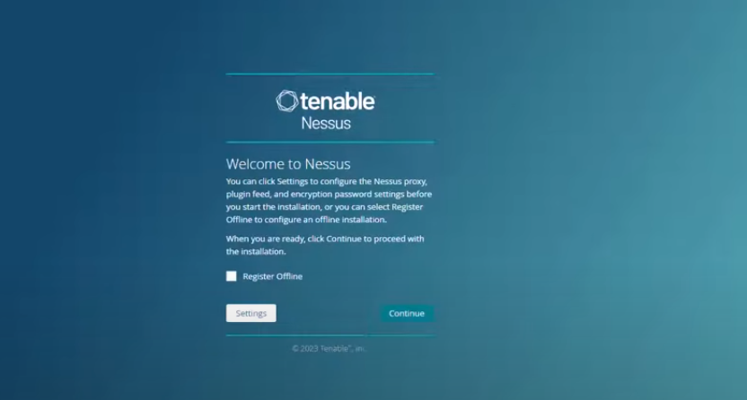

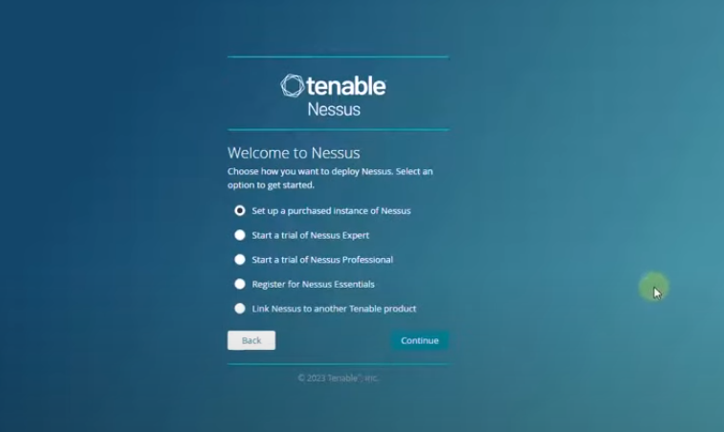

**Steps to Access the Nessus Expert Trial:**

1. Click on the option "Start the Nessus Expert Trial" on the Tenable website.
2. Paste the temporary email address that you generated earlier into the email field.
3. Create and enter a username and password of your choice. Ensure you remember these credentials for future access.
4. Complete the setup process, and you'll gain access to the Nessus Expert Trial.
5. We must wait for Plugins Download and Compile.

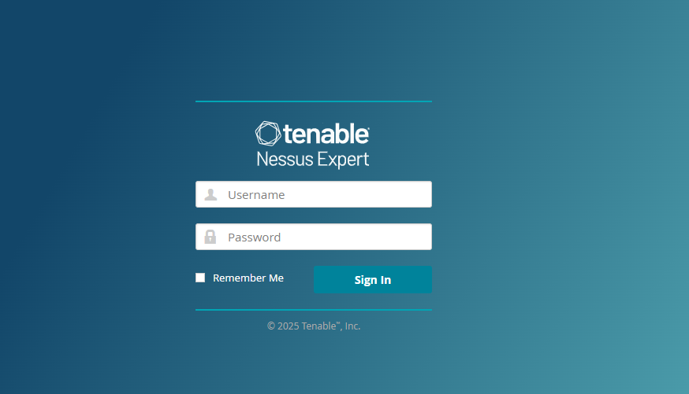

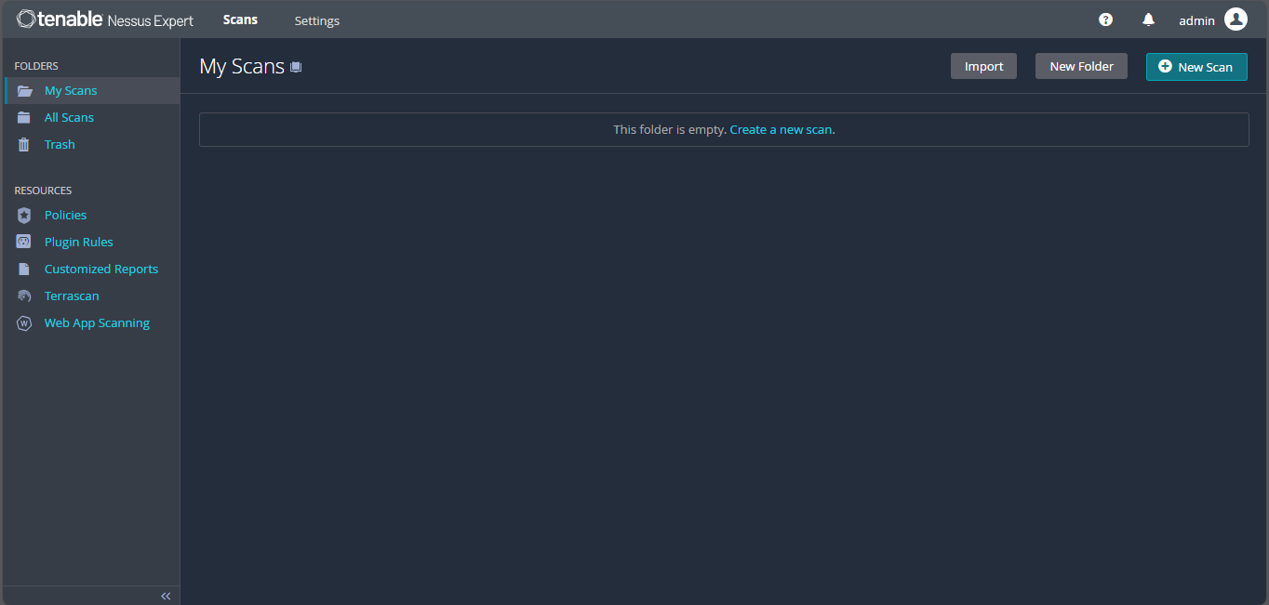

Now click on Scan and “**Advance Scan**” and Enter **Template Name or Target IP OR URL** & than just **Lunch** the Scan.

